Nepal College of Information Technology
Unit Test
Fall 2009

Program: IT-III Time: 2 hrs
Semester: Fall FM: 60
Subject: Electronic Circuits-I PM:30

Candidates are required to give their answers in their own words as far as practicable.
The figures in the margin indicate full marks.
Attempt all the questions.

1 (a) "Darlington Pair can be regarded as a 'Super β' transistor''. Comment on it with (7)
(b) For the circuit given below, find (7)
i) r_{in} _{(stage)}
ii) r_{o(stage)}
iii) voltage gain 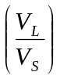
iv) ac output voltage if V_{S} = 1mv rms.
Assume 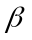=150, r_{c} =

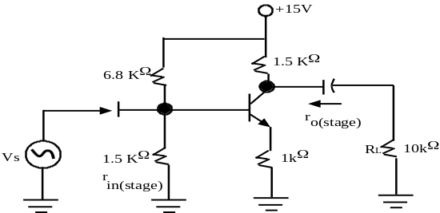

2 (a) Why Common Collector configuration amplifier is also called emitter follower? Verify your answer with the help of circuit diagram and necessary derivation. (7)
(b) Explain about the choice of transistor configuration in cascaded system? The two transistors are cascaded where the unloaded voltage gain of 1st and 2nd stages are 24 dB and 20 dB .respectively. The input resistance of 1st stage and 2nd stages are 8 KΩ and 20 KΩ respectively. Similarly the output resistances are 4 KΩ and 2 KΩ respectively. The 1st stage is driven by a source having resistance of 10 KΩ and 20 Ω load resistance is connected across the output terminal of 2nd stage. Find V_{L} / V_{S ?} ₍₃₊₄₎
3 (a) What is distortion? Explain different types of distortions with their effect on audio signal. (3+5)
(b) The amplifier shown below has mid-band gain equal to – 150. Find the approximate valve of upper cut off frequency? (7)
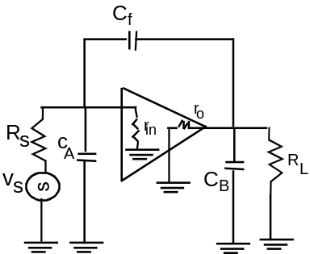

Assume: C_{A} = 50 pF, C_{B} = 60 pF, C_{f} = 20 pF,
R_{s} = 1000 Ω, r_{in} = 2000 Ω, r_{o} = 1000 Ω
R_{L} = 4.0 KΩ
4 (a) Classify the amplifiers on the basis of biasing condition? Draw Transformer Coupled load class A power amplifier and find its efficiency? (3+6)
(b) For the circuit given below, derive the expression of Lower cut off frequency due to C₁ and C₂? (8)
